**Wear Yukata!**

Yokokan Garden Stroll and Fukui Phoenix Festival

Come visit the renowned Yokokan Garden, an excellent example of Japan's traditional gardens,

and try on *yukata* for a stroll about the Phoenix Festival, Fukui’s biggest summer festival!

＊After the Yokokan visit, participants are free to use their *yukata* until 8 PM. Details on reverse.

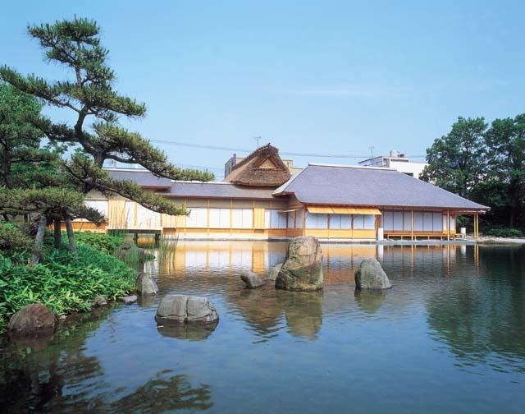

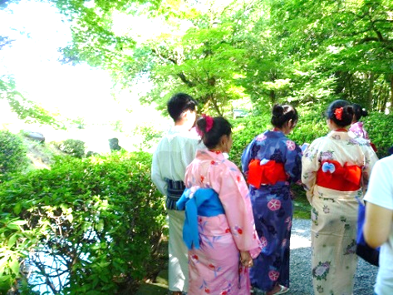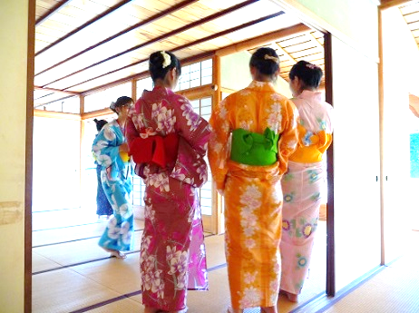

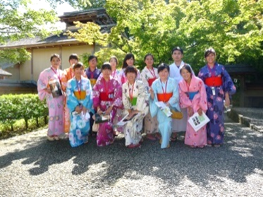

**Yokokan Garden**

**When**: Saturday, August 1, 2:00 PM～ ＊Registration from 1:45PM

**Meeting Place**:Japanese-style Room/Tea Ceremony Room, FIA 3F

＊Access…Approximately 10 minute walk from JR Fukui Station

**Open to**:Foreign residents of Fukui Prefecture, men and women (must be 150 cm in height or taller)

**Limit**: 15 people

**Cost**: 500 yen (paid at registration desk on the day of the event)

**What to Bring**: Sandals, flip flops, or other open-toed summer shoes



**How to Apply**

・Please submit your completed application (on reverse) via mail, fax, or email at the FIA.

The Microsoft Word file for the application is available on our website.

・**The deadline for applications is Saturday, July 25, or until all 15 spaces are filled, whichever**

**comes first.**

**Inquiries / Registration**: Yuki FUKUMURA, Fukui International Association

**Location**　3-1-1 Hōei, Fukui City (Approximately 10 minute walk from JR Fukui Station)

**Tel**　0776-28-8800 **Fax**　0776-28-8818　 **Email**　[info@f-i-a.or.jp](mailto:info@f-i-a.or.jp)

**Website** <http://www.f-i-a.or.jp/en/>

**Held by**: Fukui International Association

With support from the Japanese Cultural Promotion Association (NPO)





**Feel free to bring your own camera.**

**FIA staff will gladly take your picture for you.**

**Wear Yukata!** ～Yokokan Garden Stroll and Fukui Phoenix Festival～

**Schedule**

13:45 Registration ＊Where: Japanese-style Room/Tea Ceremony Room, FIA 3F

14:00 *Yukata* fitting

14:45 Depart for Yokokan Garden

Garden walk, picture taking

Depart for Phoenix Festival/Free Time

**Return to the FIA by 8:00PM to return your *yukata* and fill out our questionnaire.**

**Notes for Participants**

1. The FIA will provide *yukata* for participants, but footwear is the responsibility

of participants themselves. Hair styling is left to participants themselves

(mirrors available in the Japanese-style/Tea Room).

2. The Yokokan Garden stroll will be held regardless of weather. In the event of rain, please bring

an umbrella. If rains are especially heavy, participants can view the garden from inside its buildings.

3. If the Phoenix Festival is cancelled, participants are still free to wear the *yukata* until 8:00 PM.

